

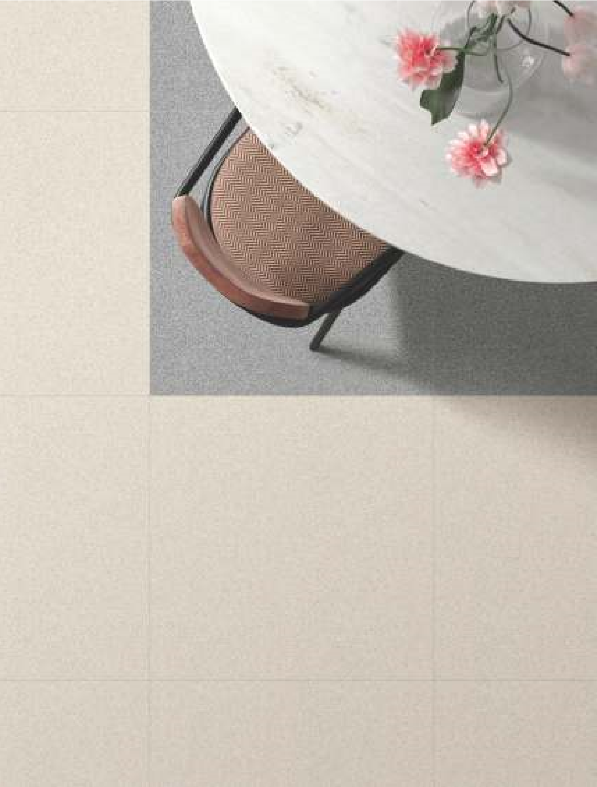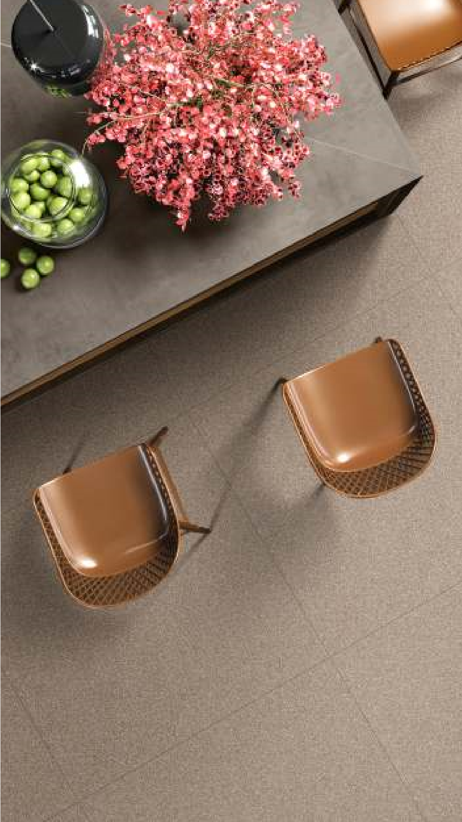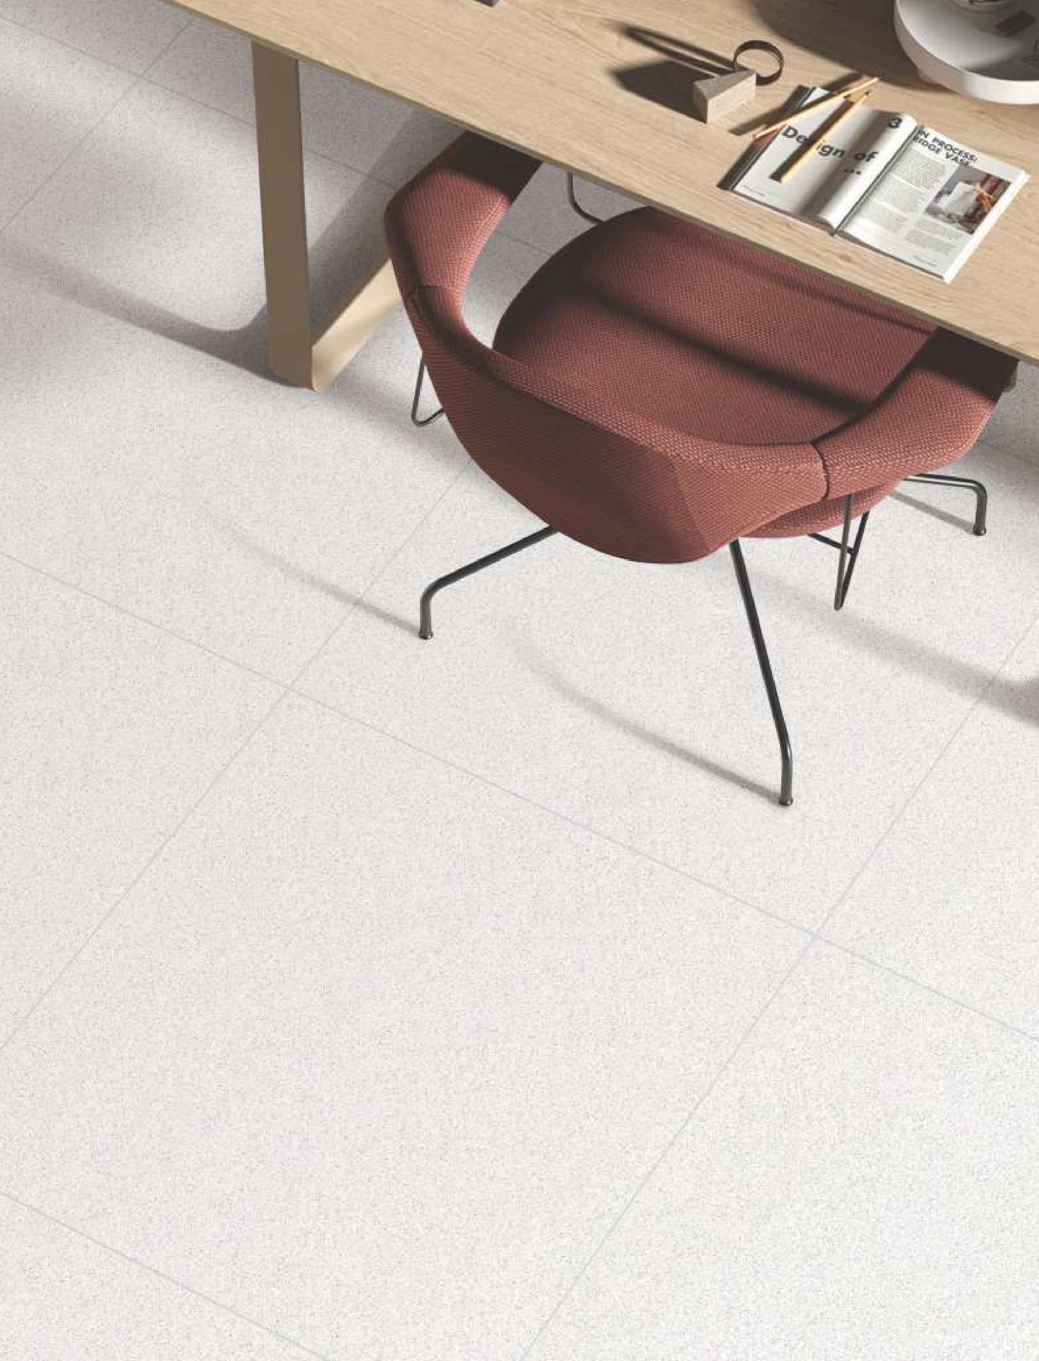

|

SURFACE :

**Glazed Vitrified Tiles**

Cera’s Limited

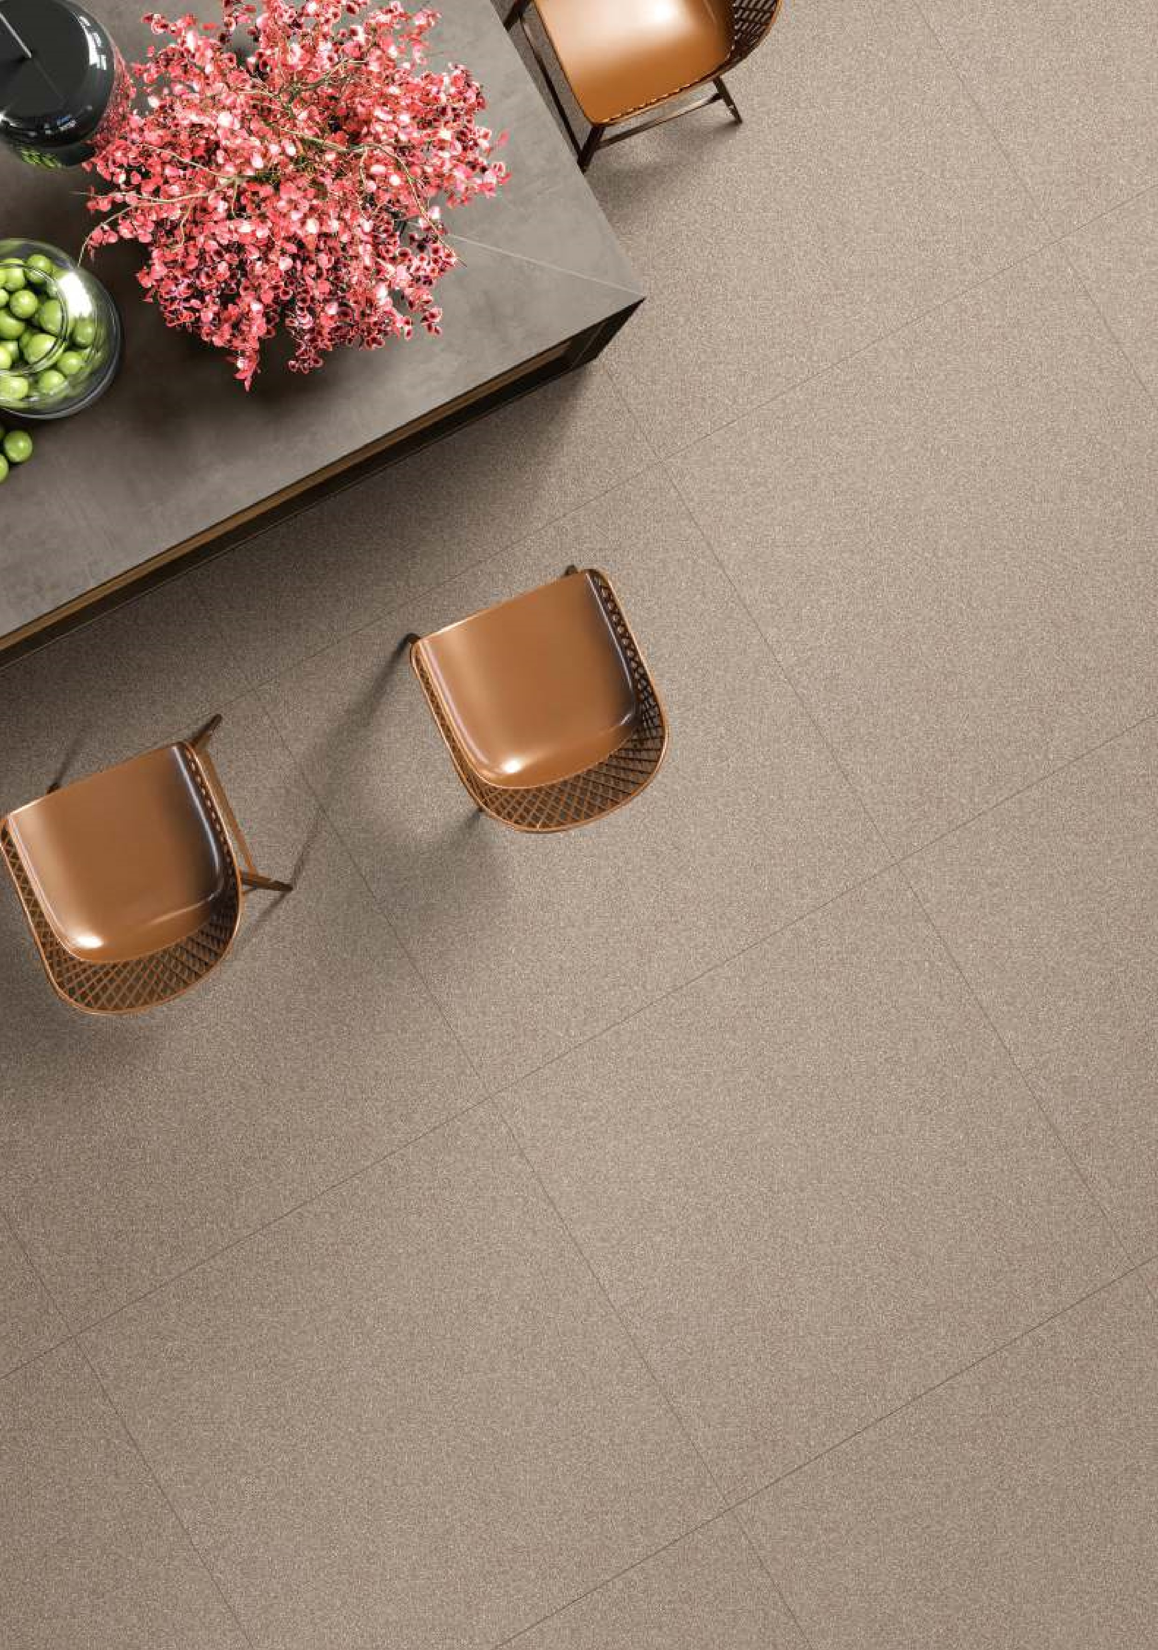

**FULL BODY**

**DELPHI**

**80**

**x120 cm**

|

**80**

**x80 cm**

|

**60**

**x60 cm**

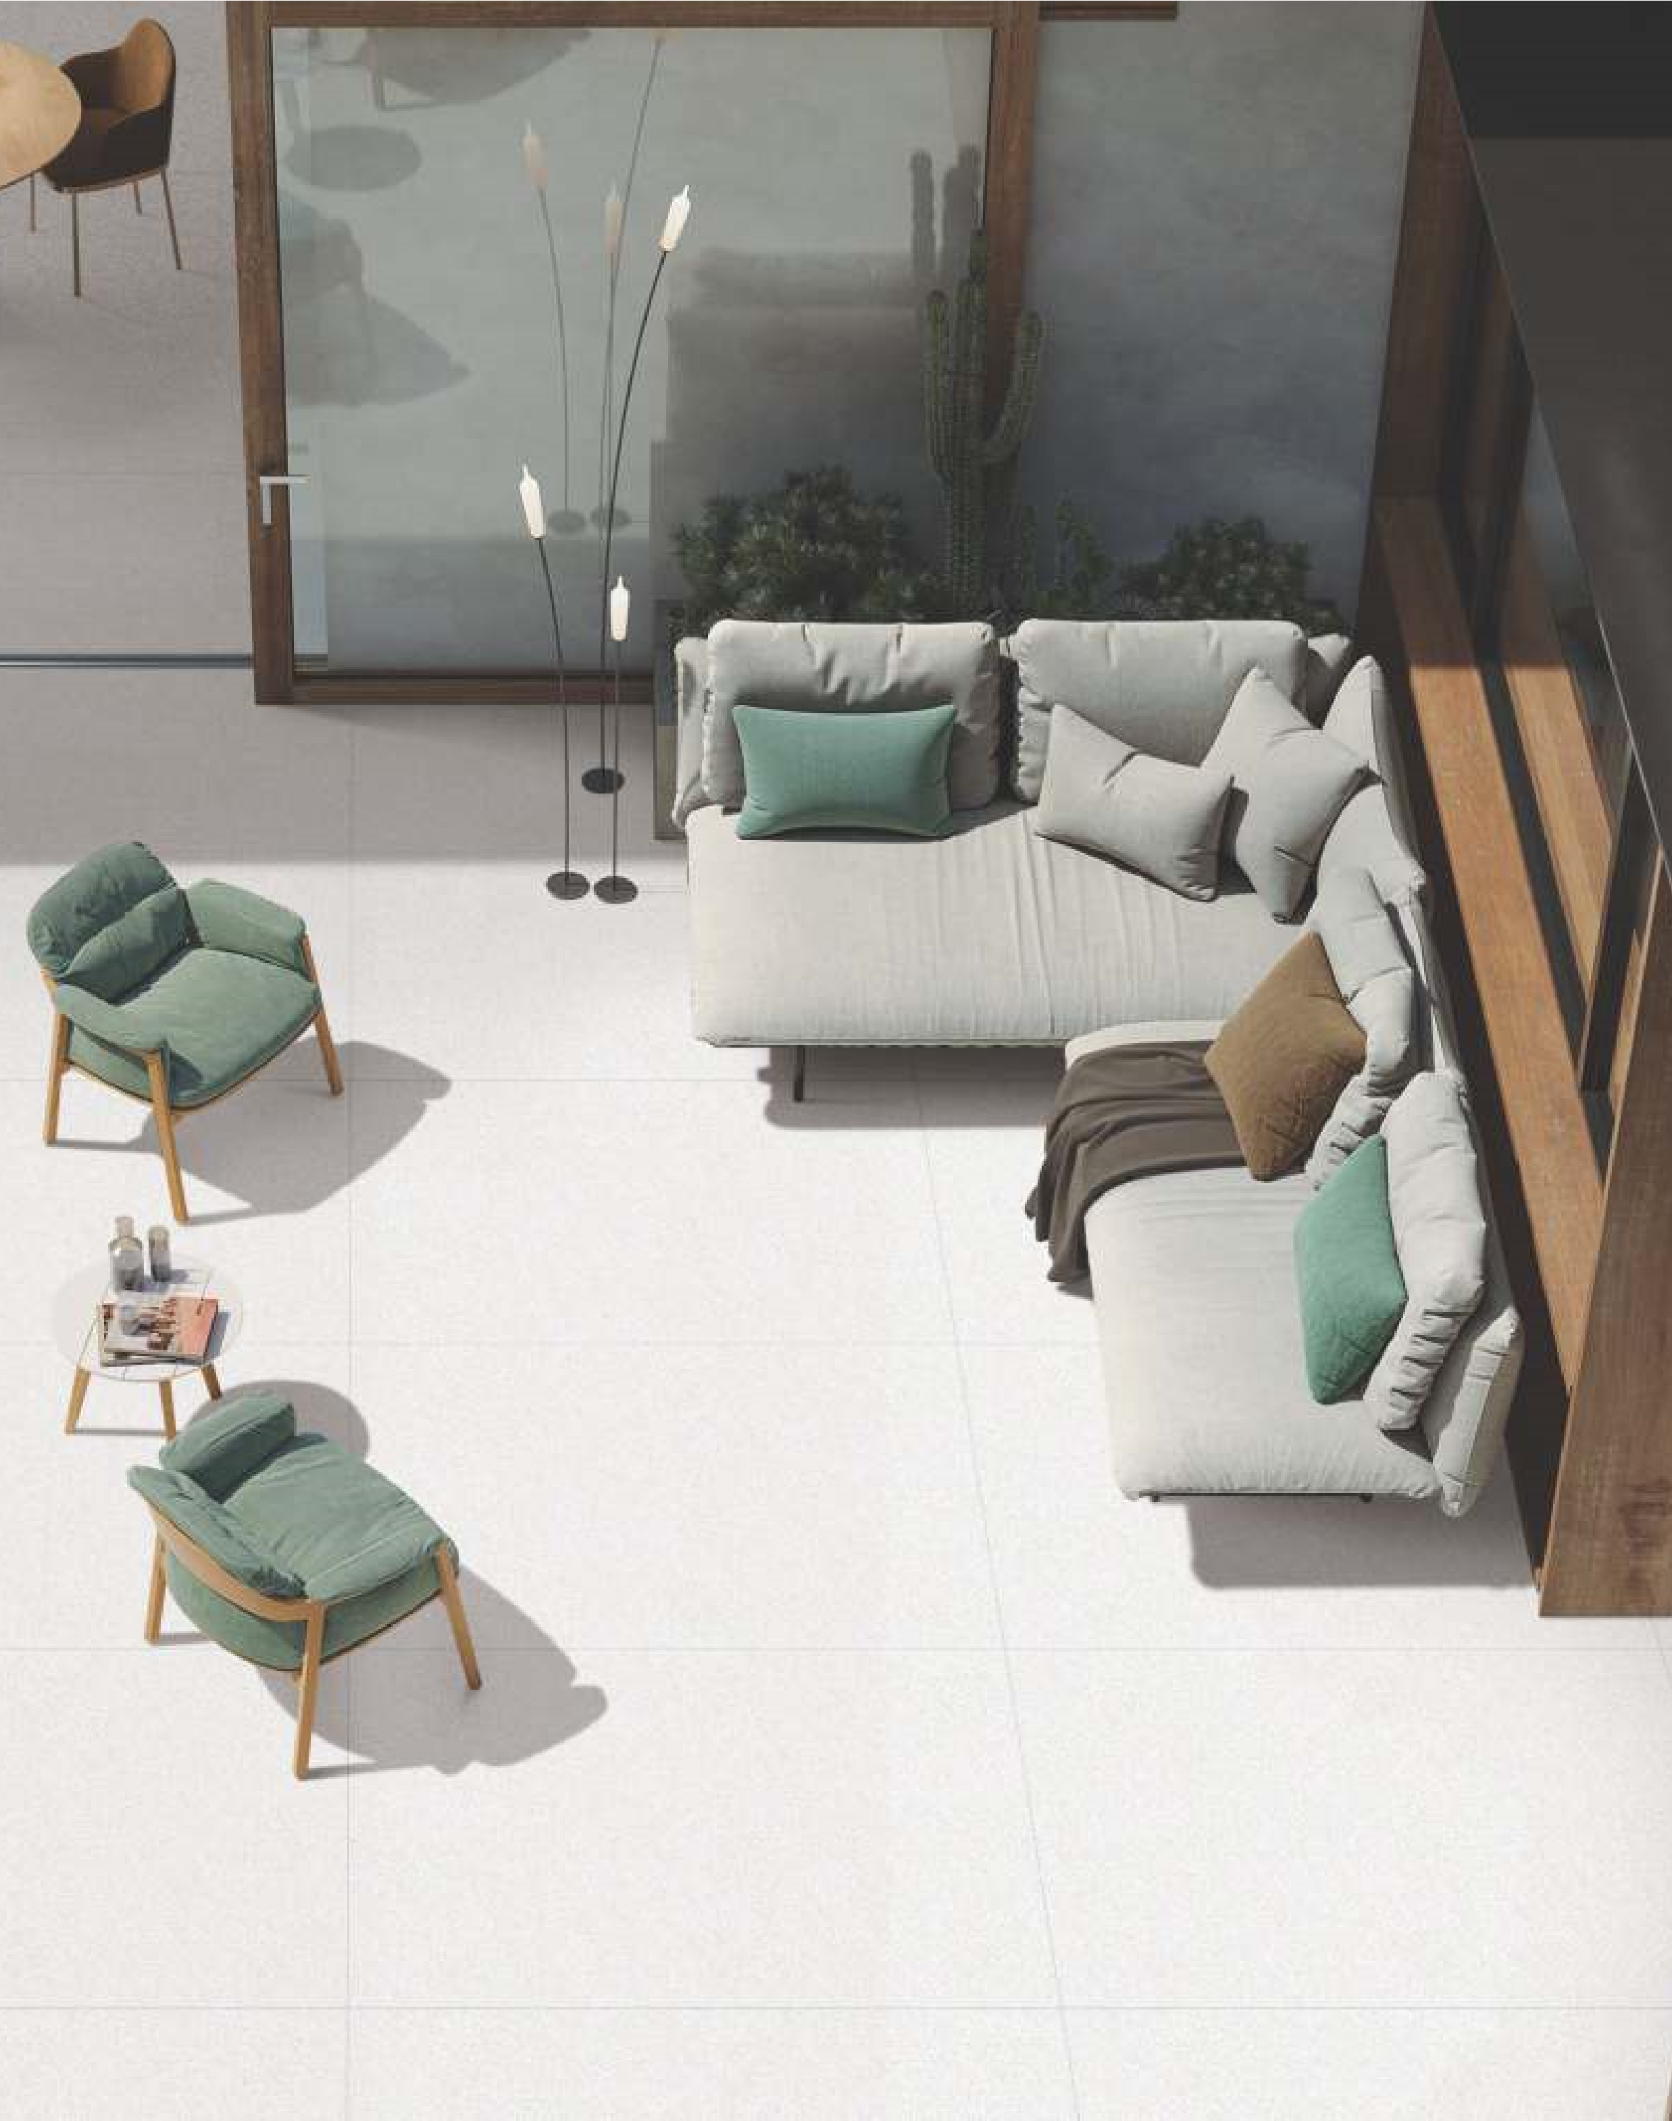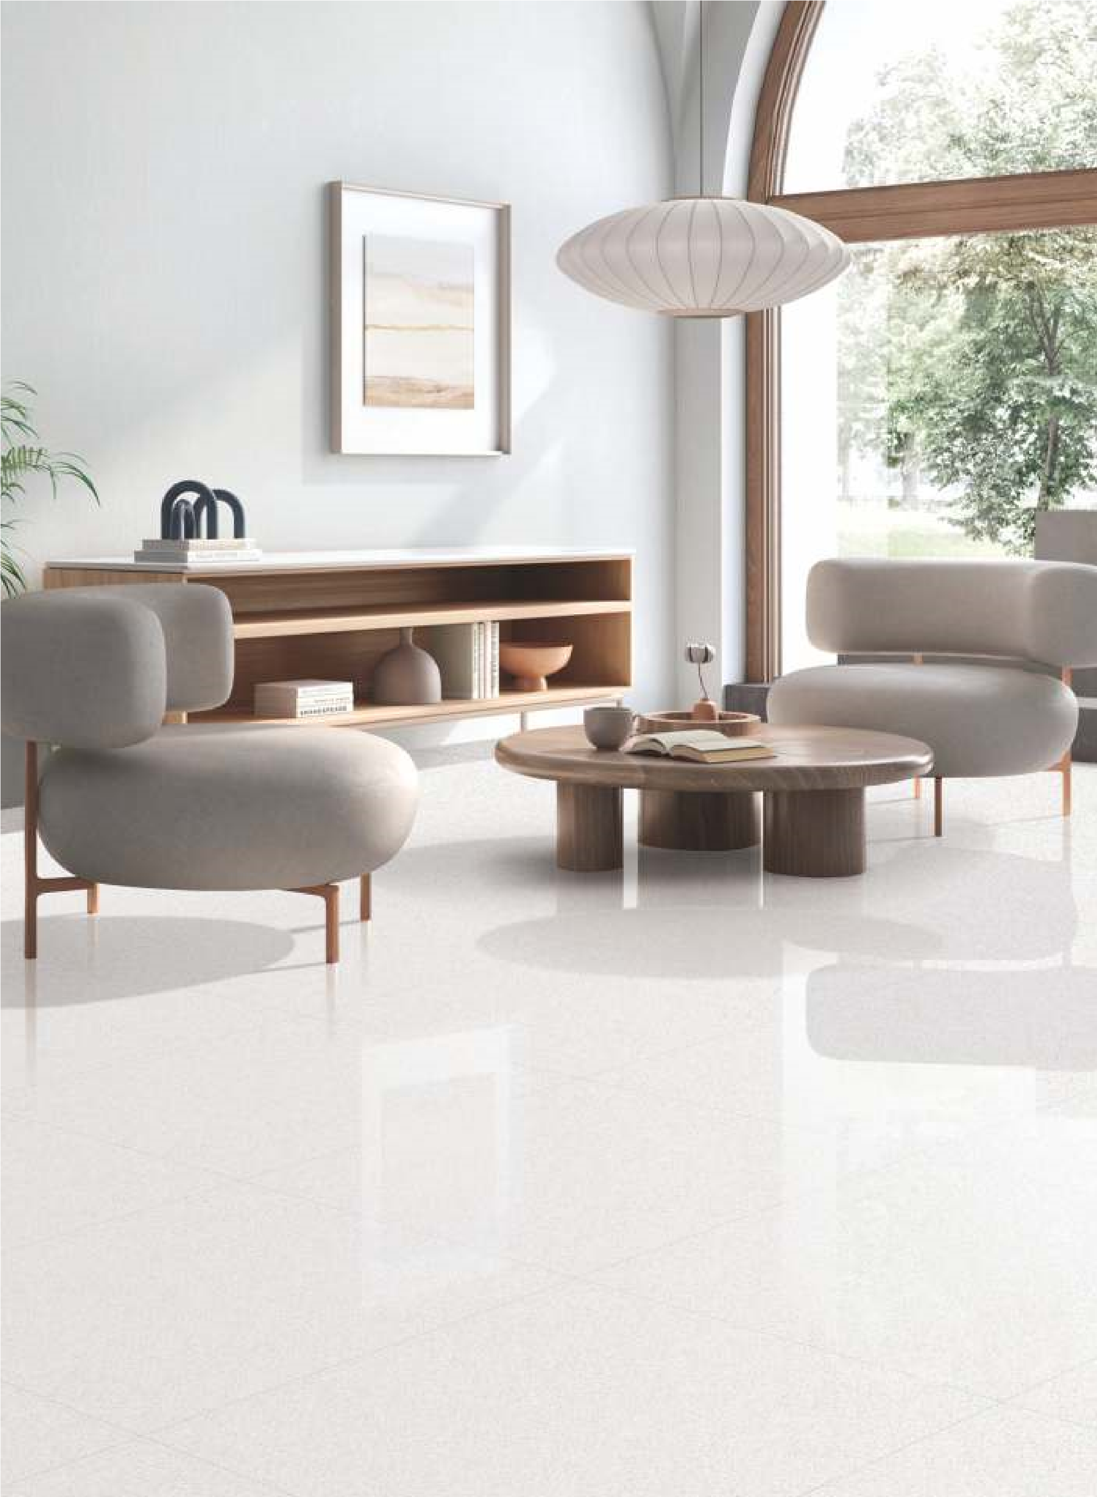

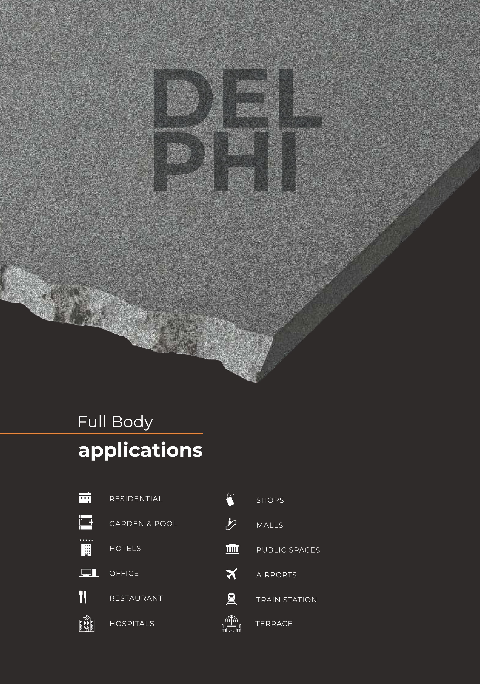

**May 2022**

**Cera’s Ceramic Limited**

Shop # R-378 SEC 31/B KDA Employees Korangi Karachi.

**Cera’s**

Tiles Company